CTM-I Use Case

Field Security Maintenance

Version 0.1

Use Case Name | Field Security Maintenance
Actor | App Support
Pre-conditions /Assumptions | At least one Firm Level Security Role has been defined in the system.  User has rights to access the Field Security Maintenance page.  User has selected the Field Security Maintenance option from the Menu.
Post Conditions | The user has the option of returning to the Field Security Use Case.
Screenshot | 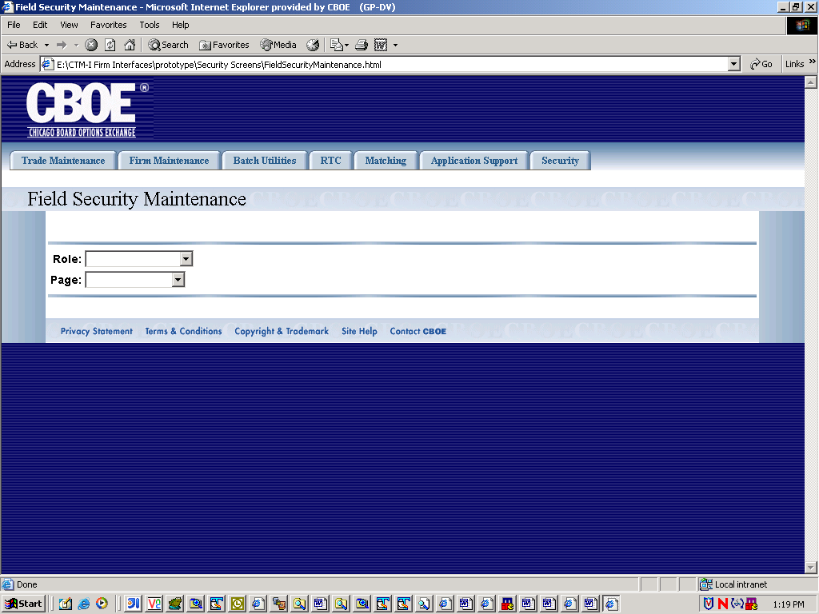  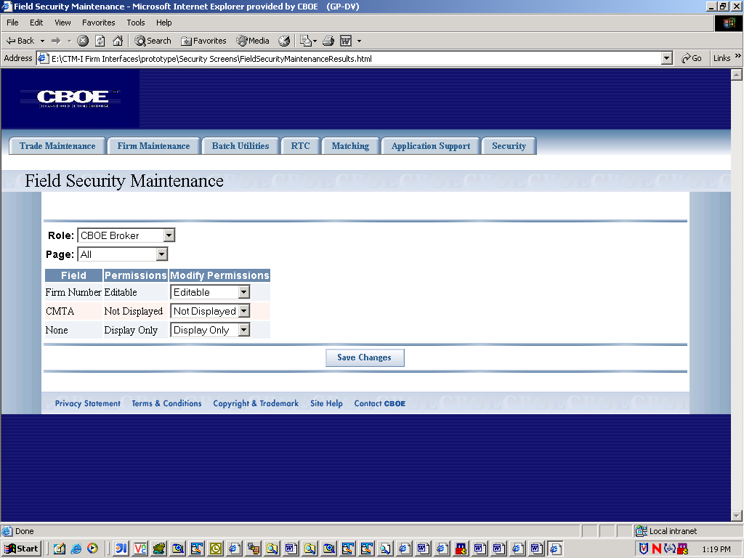
Flow of Events
   | User | System
  1 | User logs into CTMI application | System verifies that user has rights to maintain Roles. If user has rights, User Maintenance menu is displayed
  2 | User selects the Field Permission  Maintenance option
  3. |  | System displays the Field Permission Maintenance screen
  4 | User selects a role from a list of roles
  5. | User selects a CTMI Page.
  6. |  | System retrieves fields for the specified Role and page, and displays the following:  Field –Display Only Contains the name of the field.  Permissions. The currently assigned permissions for the field.  Modify Permissions. Editable field. User has option of changing the permission.
  7. | User changes permission (from selection of valid permissions) for any number of fields and submits changes to system.
  8. |  | System persists the field permission data.  System logs an entry in a security audit, containing the following  Field Id  Permission Id (for new permission)  Last Updated- current date/time  System displays a confirmation message stating that the permissions were saved.  System redisplays the following fields  Field –Display Only Contains the name of the field.  Permissions. The currently assigned permissions for the field.  Modify Permissions. Editable field. User has option of changing the permission.
Alternative Path | 5.1 User selects the “All” option for the Page field, and the system returns all fields associated with the selected Role.

